PIZZA SALES SQL QUERIES
KPI’s
- Total Revenue
Select sum(total_price) AS Total_Revenue
from pizzaorder
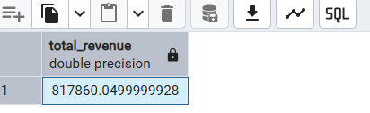

2. Average Order Values
select sum(total_price)/count(distinct order_id) as Avg_Order_Value from pizzaorder
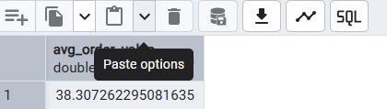

3. Total Pizza Sold
select sum(quantity) as Total_pizza_sold from pizzaorder
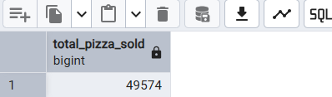

4. Total Orders Placed
select count(distinct order_id) as Total_order from pizzaorder

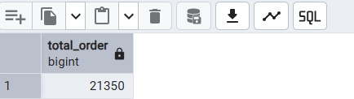

5. Average Pizzas Per Order
select cast(cast(sum(quantity) as decimal(10,2))/cast(count(distinct order_id) as decimal(10,2)) as decimal(10,2)) as Average_pizzas_per_order from pizzaorder
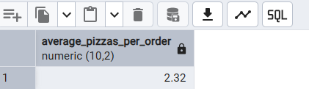

6. Daily Trend For Total Orders
select to_char(order_date,'Day') as order_day,count(distinct order_id) as Total_orders from pizzaorder
group by to_char(order_date,'Day')
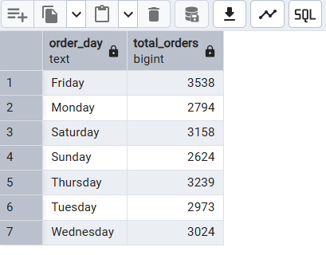
7. Hour Trend For Total Orders
select extract(hour from order_time) as timing ,count(distinct order_id) from pizzaorder
group by extract(hour from order_time) order by extract(hour from order_time)
select extract(hour from order_time ) as order_hour,count(distinct order_id) as total_order from pizzaorder
group by extract(hour from order_time ) order by extract(hour from order_time )
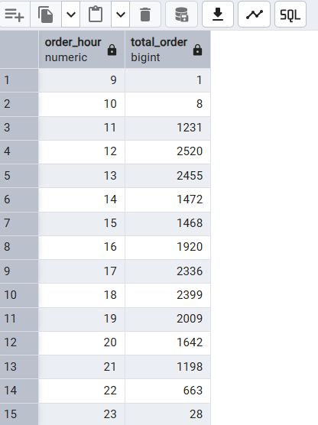

8. % of Sales by Pizza Category
select pizza_category,sum(total_price)*100.0/(select sum(total_price) from pizzaorder ) as percentage_of_total_sales from pizzaorder
group by pizza_category
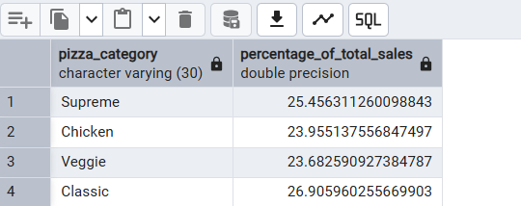

NOTE
If you want to apply the Month, Quarter, Week filters to the above query you can use WHERE clause. For Example
select pizza_category,sum(total_price)*100.0/(select sum(total_price) from pizzaorder where extract(month from order_date) =1
) as percentage_of_total_sales from pizzaorder
group by pizza_category
where extract(month from order_date) =1

9. % of Sales by Pizza Size
select pizza_size, cast(sum(total_price)*100.0/(select sum(total_price) from pizzaorder ) as decimal(10,2)) as percentage_of_total_sales from pizzaorder

group by pizza_size order by percentage_of_total_sales desc

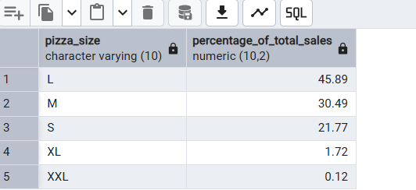

10. Total Pizzas Sold Per Category
select pizza_category,sum(quantity) as total_pizzas_sold_per_category from pizzaorder
group by pizza_category
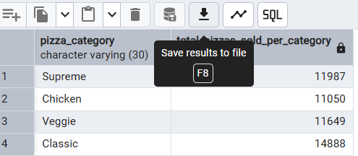

11. Top 5 Best Selling Pizza
select pizza_name,sum(quantity) as total_pizzas_sold from pizzaorder group by pizza_name order by total_pizzas_sold desc limit 5
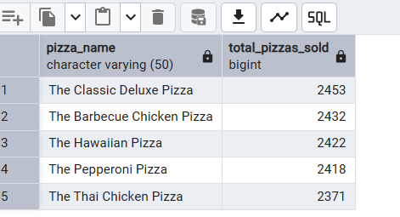

12. Top 5 Less Selling Pizzas
select pizza_name,sum(quantity) as total_pizzas_sold from pizzaorder group by pizza_name order by total_pizzas_sold asc limit 5

